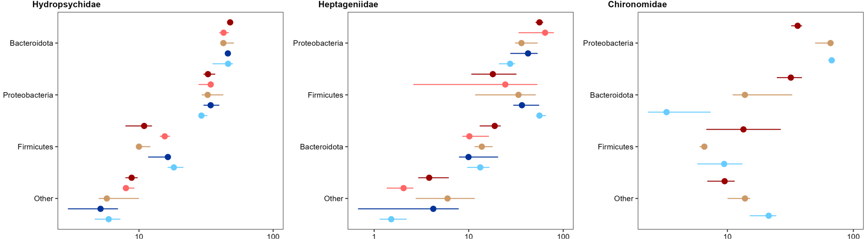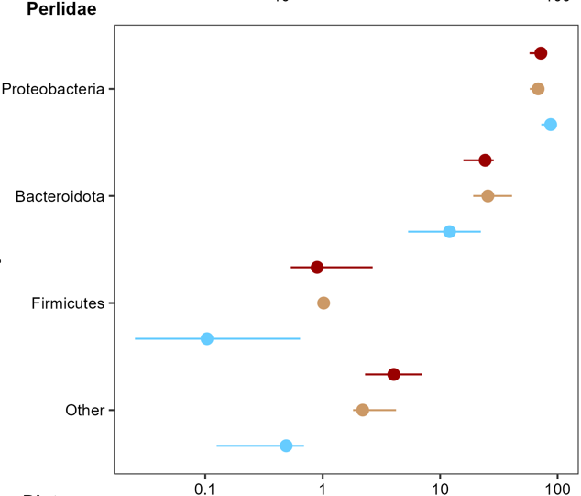

Relative Abundance (%)

Phylum

Spiders

Adults

Larvae